# Design Specification

## Introduction

Design is the important factor of the software development process. It helps to plan the interface and architecture of the system. In this process, overall design and overview of the system is defined. Since all the modules are break down into smaller and manageable parts, the development and designing of the system are easy, efficient and effective. Design specification consist of various activities such as class diagram, activity diagram, ER diagram and so on.

## Structural Model

Structural model holds the static feature of the system. It is the view of entire system with object, attributes and their relationships.

### Class Diagram

Class diagram is the logical structure of the system.

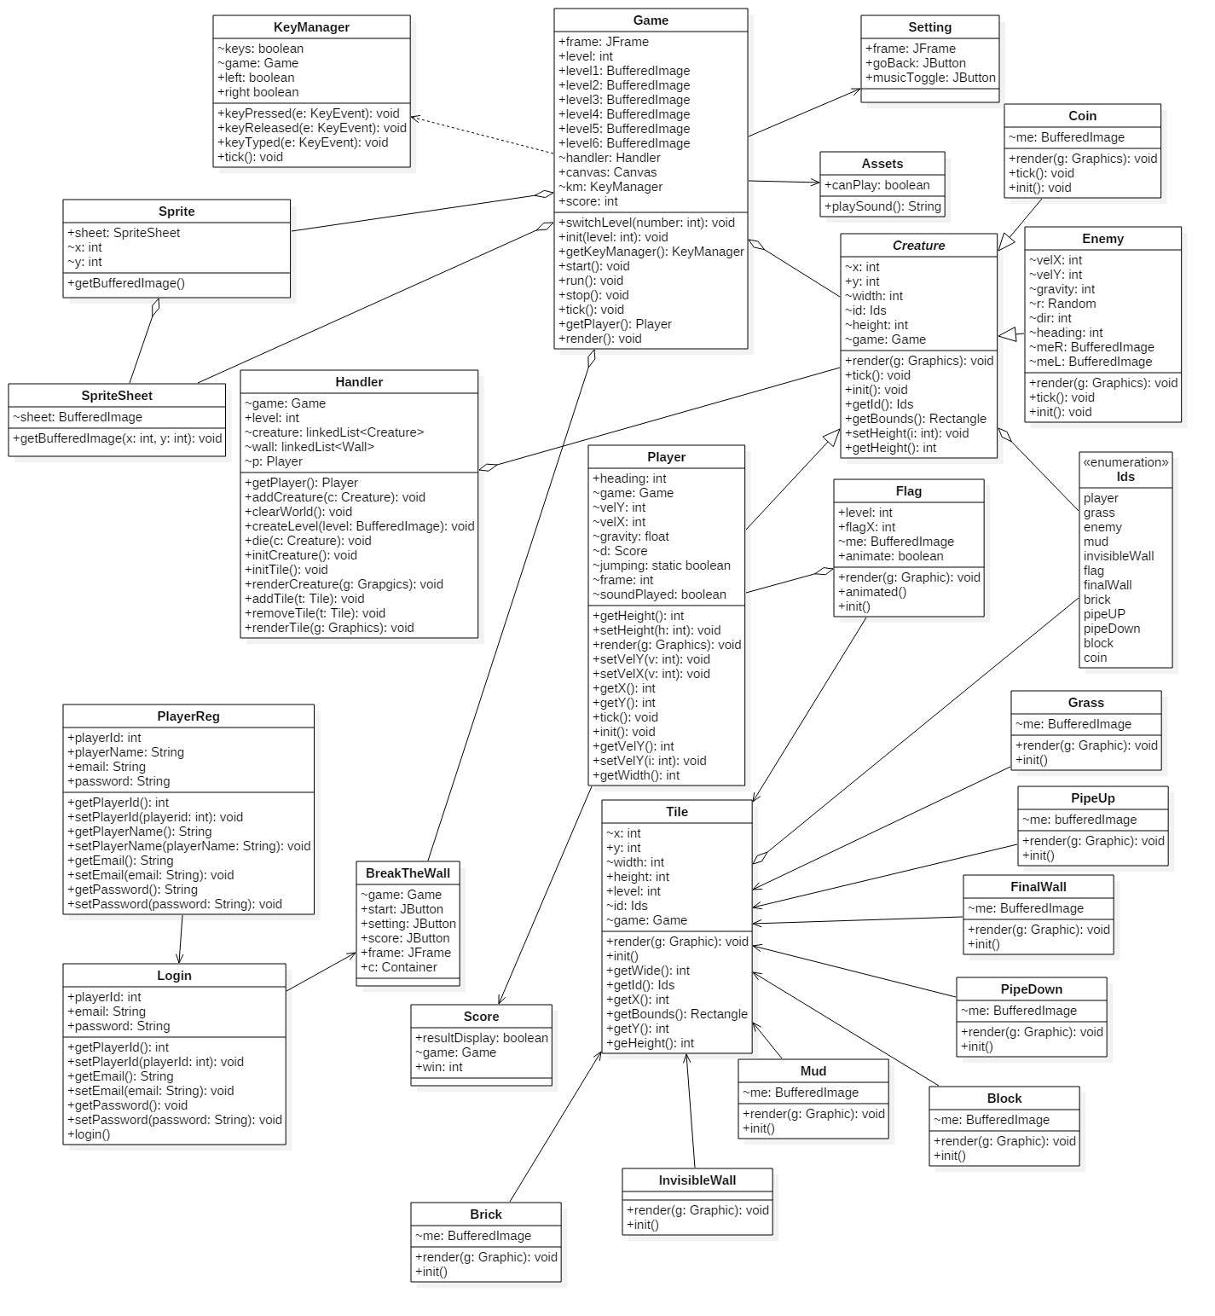

Fig: Class Diagram

## Behavioral Model

It is the diagram which describes the interaction and dynamic features of system. It provides details information about the data processing and managing within the system.

### Sequence Diagram

It is the behavioral diagram that describes the interaction among classes. It is also known as event diagram. It helps to determine the system’s work or behavior. Different types of notation are used in sequence diagram.

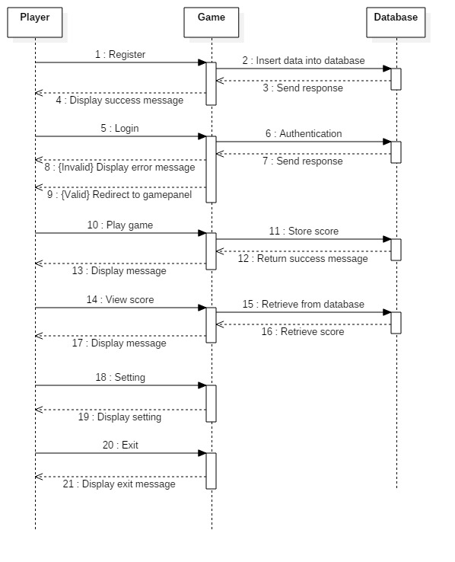

Fig: Sequence diagram

### Activity Diagram

It is the behavioral diagram that us used to print sequence of activity which describes the flow of one activity to another activity. The helps to determine the work flow from start point to end point.

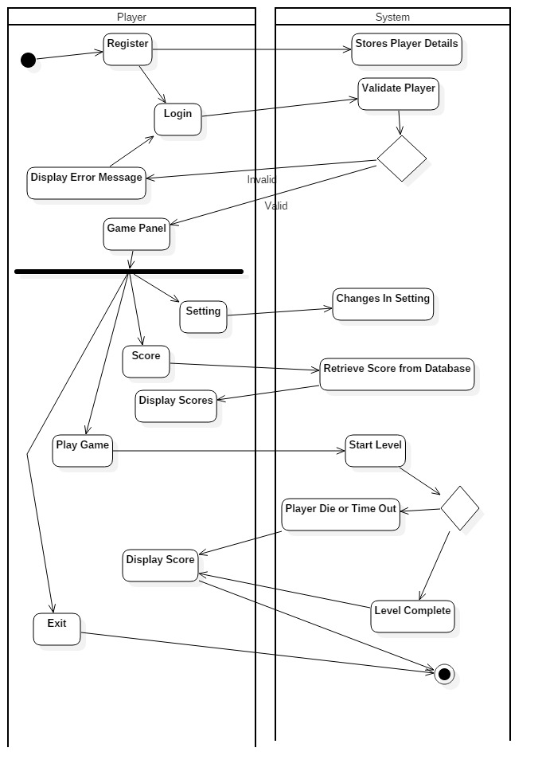

Fig: Activity Diagram

### Database Model

It is the logical structure of a database that includes relationships and constraints. It helps to determine the data store and retrieve in the system.

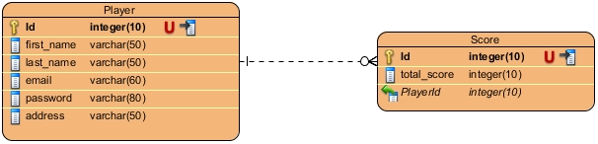

Fig: ER Diagram

# Conclusion

An appropriate documentation on design specification of Break the Wall game is accomplished. At first, all the design phases are identified. Then necessary processes such as structural model, behavioral model and database model are drawn. In this model diagrams are established like class diagram, activity diagram and sequence diagram and ER diagram.